**Осень 2024 г. Объектно-ориентированное программирование**

**HW (10 баллов)**

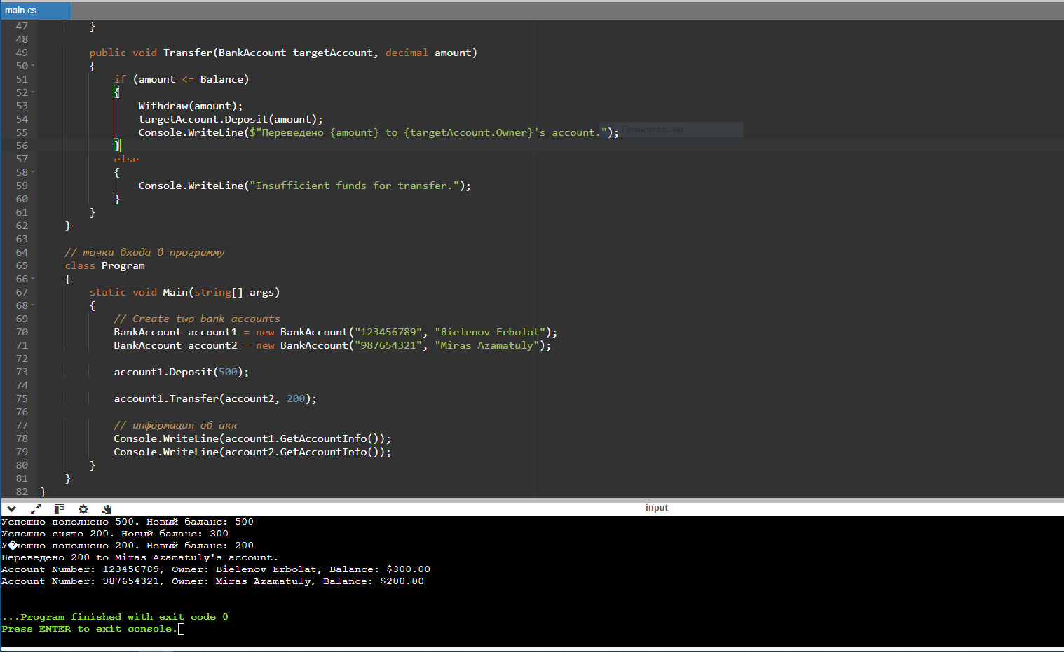

using System;

namespace BankApp

{

public class BankAccount

{

public string AccountNumber { get; private set; }

public decimal Balance { get; private set; }

public string Owner { get; private set; }

public BankAccount(string accountNumber, string owner)

{

AccountNumber = accountNumber;

Owner = owner;

Balance = 0;

}

public void Deposit(decimal amount)

{

if (amount > 0)

{

Balance += amount;

Console.WriteLine($"Успешно пополнено {amount}. Новый баланс: {Balance}");

}

else

{

Console.WriteLine("Deposit amount must be positive.");

}

}

public void Withdraw(decimal amount)

{

if (amount <= Balance)

{

Balance -= amount;

Console.WriteLine($"Успешно снято {amount}. Новый баланс: {Balance}");

}

else

{

Console.WriteLine("Insufficient funds.");

}

}

public string GetAccountInfo()

{

return $"Account Number: {AccountNumber}, Owner: {Owner}, Balance: {Balance:C}";

}

public void Transfer(BankAccount targetAccount, decimal amount)

{

if (amount <= Balance)

{

Withdraw(amount);

targetAccount.Deposit(amount);

Console.WriteLine($"Переведено {amount} to {targetAccount.Owner}'s account.");

}

else

{

Console.WriteLine("Insufficient funds for transfer.");

}

}

}

// точка входа в программу

class Program

{

static void Main(string[] args)

{

// Create two bank accounts

BankAccount account1 = new BankAccount("123456789", "Bielenov Erbolat");

BankAccount account2 = new BankAccount("987654321", "Miras Azamatuly");

account1.Deposit(500);

account1.Transfer(account2, 200);

// информация об акк

Console.WriteLine(account1.GetAccountInfo());

Console.WriteLine(account2.GetAccountInfo());

}

}

}

